

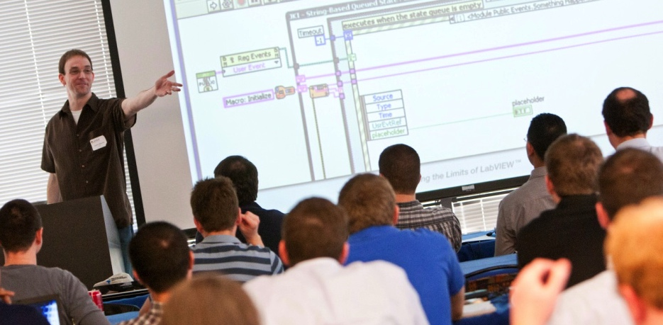

LabVIEW Center of Excellence – Self Assessment

# Audit Summary

[Note: After going through the detailed items, fill out this high level summary and update over time]

|  |  |  |
| --- | --- | --- |
| **Engineer Good Software** | **Engage in Community Learning** | **Ensure Technical Leadership** |
| Requirements Gathering & Tracking | Organizational Proficiency Plan | Designated Technical Lead |
| Design & Code Reviews | Internal Onboarding | Development Environment & Core Concepts |
| Standard Libraries & Templates | Internal User Group | CLD Mastery |
| Code Management | Learning & Development Plan | Architecture Mastery |
| Software Testing & Release | External & Global Community | Software Deployment & Distribution |

Summary:

[Summarize high level goals here]

The recommendations include:

[Call out specific team recommendations]

Contents

Audit Summary 2

Engineer Good Software 3

Requirements Gathering and Tracking 3

Design Reviews 4

Code Reviews 4

Standard (Reuse) Libraries and Templates 5

Code Management - Source Code Control 7

Software Testing and Release 8

Engage in Continuous Community Learning 10

Organizational Proficiency Plan 10

Internal Onboarding 10

Internal User Group (for smaller teams, mentoring may suffice) 11

Learning & Development Plan 11

External and Global Community 12

Ensure Technical Knowledge 13

Designated Technical Lead 13

Development Environment and Core Concepts 13

CLD Mastery 14

Architecture Mastery 14

Software Deployment and Distribution 16

# Engineer Good Software

## Requirements Gathering and Tracking

|  |  |  |
| --- | --- | --- |
| Status: Complete | Required | **Team has a process for gathering requirements for a project** |
| Notes: | | |
| Resources: | | |

|  |  |  |
| --- | --- | --- |
| Status: In process | Required | **Team has a process for tracking and updating requirements** |
| Notes: | | |
| Resources: | | |

|  |  |  |
| --- | --- | --- |
| Status: Incomplete | Required | **Team has a process for managing changes in requirements** |
| Notes: | | |
| Resources: | | |

|  |  |  |
| --- | --- | --- |
| Status: | Optional | **Team documents the cost (time and money) to integrate the change** |
| Notes: | | |
| Resources: | | |

|  |  |  |
| --- | --- | --- |
| Status: | Optional | **Team has a process for signing off on the change** |
| Notes: | | |
| Resources: | | |

## Design Reviews

|  |  |  |
| --- | --- | --- |
| Status: | Required | **Team conducts iterative design reviews for all projects** |
| Notes: | | |
| Resources: | | |

|  |  |  |
| --- | --- | --- |
| Status: | Required | **Team has a process for capturing and resolving issues found during design reviews** |
| Notes: | | |
| Resources: | | |

## Code Reviews

|  |  |  |
| --- | --- | --- |
| Status: | Required | **A style guide is used by the team** |
| Notes: | | |
| Resources: | | |

|  |  |  |
| --- | --- | --- |
| Status: | Optional | **The team style guide includes company-specific recommendations** |
| Notes: | | |
| Resources: | | |

|  |  |  |
| --- | --- | --- |
| Status: | Required | **Team uses VI Analyzer as part of the code review process** |
| Notes: | | |
| Resources: | | |

|  |  |  |
| --- | --- | --- |
| Status: | Optional | **Team has added unique tests to VI Analyzer** |
| Notes: | | |
| Resources: | | |

|  |  |  |
| --- | --- | --- |
| Status: | Required | **Team has a code review process** |
| Notes: | | |
| Resources: | | |

|  |  |  |
| --- | --- | --- |
| Status: | Required | **Team has a process for capturing and resolving issues found during the code review** |
| Notes: | | |
| Resources: | | |

## Standard (Reuse) Libraries and Templates

|  |  |  |
| --- | --- | --- |
| Status: | Required | **For each project, the team identifies opportunity for reuse** |
| Notes: | | |
| Resources: | | |

|  |  |  |
| --- | --- | --- |
| Status: | Required | **The team should maintain a base of reuse code that is relevant and contributes to improved code quality.** |
| Notes: | | |
| Resources: | | |

|  |  |  |
| --- | --- | --- |
| Status: | Required | **A style guideline is followed for the creation of libraries and templates and any code that supports the team's framework** |
| Notes: | | |
| Resources: | | |

|  |  |  |
| --- | --- | --- |
| Status: | Optional | **The style guide includes a section that details how the team will document code and deliverables.** |
| Notes: | | |
| Resources: | | |

|  |  |  |
| --- | --- | --- |
| Status: | Required | **Team has a process for maintaining and updating libraries as needed** |
| Notes: | | |
| Resources: | | |

|  |  |  |
| --- | --- | --- |
| Status: | Required | **Technical lead can define tasks that should be automated and executes on automating those tasks** |
| Notes: | | |
| Resources: | | |

## Code Management - Source Code Control

|  |  |  |
| --- | --- | --- |
| Status: | Required | **Team has selected a SCC solution** |
| Notes: | | |
| Resources: | | |

|  |  |  |
| --- | --- | --- |
| Status: Complete | Required | **Team has determined what will and will not be kept under SCC** |
| Notes: | | |
| Resources: | | |

|  |  |  |
| --- | --- | --- |
| Status: Complete | Required | **Team has determined how to organize the repository** |
| Notes: | | |
| Resources: | | |

|  |  |  |
| --- | --- | --- |
| Status: Complete | Required | **Team has determined commit / push cadence** |
| Notes: | | |
| Resources: | | |

|  |  |  |
| --- | --- | --- |
| Status: Complete | Required | **Team has designs code and procedures to minimize the potential for merge conflicts (directory or binary)** |
| Notes: | | |
| Resources: | | |

## Software Testing and Release

|  |  |  |
| --- | --- | --- |
| Status: | Required | **Team has a test plan and demonstrates that it has been implemented.** |
| Notes: | | |
| Resources: | | |

|  |  |  |
| --- | --- | --- |
| Status: | Required | **The team uses automated testing where it is feasible.** |
| Notes: | | |
| Resources: | | |

|  |  |  |
| --- | --- | --- |
| Status: | Optional | **Reuse code is unit tested** |
| Notes: | | |
| Resources: | | |

|  |  |  |
| --- | --- | --- |
| Status: | Optional | **Project code is unit tested** |
| Notes: | | |
| Resources: | | |

|  |  |  |
| --- | --- | --- |
| Status: | Optional | **Team leverages Desktop Execution Trace Toolkit to test for memory leaks.** |
| Notes: | | |
| Resources: | | |

|  |  |  |
| --- | --- | --- |
| Status: | Optional | **Team leverages Desktop Execution Trace Toolkit for additional testing** |
| Notes: | | |
| Resources: | | |

|  |  |  |
| --- | --- | --- |
| Status: | Optional | **Team has a process for integration testing as needed** |
| Notes: | | |
| Resources: | | |

|  |  |  |
| --- | --- | --- |
| Status: | Optional | **Team has a process for customer acceptance test as needed** |
| Notes: | | |
| Resources: | | |

# Engage in Continuous Community Learning

## Organizational Proficiency Plan

|  |  |  |
| --- | --- | --- |
| Status: | Optional | **Team conducts yearly skills assessment** |
| Notes: | | |
| Resources: | | |

|  |  |  |
| --- | --- | --- |
| Status: | Required | **Team drafts and executes yearly proficiency plan** |
| Notes: | | |
| Resources: | | |

## Internal Onboarding

|  |  |  |
| --- | --- | --- |
| Status: | Required | **Internal training bridges the gap between NI training and being productive on the company LabVIEW team.** |
| Notes: | | |
| Resources: | | |

|  |  |  |
| --- | --- | --- |
| Status: | Required | **Processes under "Engineer Good Software" have been clearly documented.** |
| Notes: | | |
| Resources: | | |

|  |  |  |
| --- | --- | --- |
| Status: | Optional | **A process exists to confirm that the new individual is ready to effectively contribute to the code base** |
| Notes: | | |
| Resources: | | |

## Internal User Group (for smaller teams, mentoring may suffice)

|  |  |  |
| --- | --- | --- |
| Status: In work | Required | **Meetings are conducted at least 6 times per year.** |
| Notes: | | |
| Resources: | | |

|  |  |  |
| --- | --- | --- |
| Status: | Required | **A designated individual(s) drives a focused agenda**. |
| Notes: | | |
| Resources: | | |

## Learning & Development Plan

|  |  |  |
| --- | --- | --- |
| Status: | Required | **Team has a training and certification plan for designated individuals (see section on Ensure Technical Knowledge).** |
| Notes: | | |
| Resources: | | |

|  |  |  |
| --- | --- | --- |
| Status: Incomplete | Required | **Teams demonstrate execution of the training and certification plan** |
| Notes: | | |
| Resources: | | |

## External and Global Community

|  |  |  |
| --- | --- | --- |
| Status: | Required | **Designated individuals attend regional user groups if available.** |
| Notes: | | |
| Resources: | | |

|  |  |  |
| --- | --- | --- |
| Status: | Required | **Designated individuals attend Developer Days, NI Days, NIWeek if available.** |
| Notes: | | |
| Resources: | | |

|  |  |  |
| --- | --- | --- |
| Status: | Optional | **Designated individuals engage in the forums or monitor relevant discussions.** |
| Notes: | | |
| Resources: | | |

# Ensure Technical Knowledge

## Designated Technical Lead

|  |  |  |
| --- | --- | --- |
| Status: | Required | **A technical lead has been designated** |
| Notes: | | |
| Resources: | | |

|  |  |  |
| --- | --- | --- |
| Status: | Required | **Attaining CLA is part of the employee's yearly review** |
| Notes: | | |
| Resources: | | |

|  |  |  |
| --- | --- | --- |
| Status: | Required | **An individual who will drive software process standards has been designated. (could be the same as above)** |
| Notes: | | |
| Resources: | | |

## Development Environment and Core Concepts

|  |  |  |
| --- | --- | --- |
| Status: | Required | **Specific roles/team members who only need Core 1 (and potentially Core 2) understanding have been identified.** |
| Notes: | | |
| Resources: | | |

|  |  |  |
| --- | --- | --- |
| Status: | Required | **Process for proving understanding has been established (could be CLAD certification)** |
| Notes: | | |
| Resources: | | |

|  |  |  |
| --- | --- | --- |
| Status: | Required | **Team members have proven understanding**. |
| Notes: | | |
| Resources: | | |

## CLD Mastery

|  |  |  |
| --- | --- | --- |
| Status: Complete | Required | **Two individuals have attained CLD certification** |
| Notes: | | |
| Resources: | | |

|  |  |  |
| --- | --- | --- |
| Status: | Required | **Team has determined who needs a CLD skill set** |
| Notes: | | |
| Resources: | | |

## Architecture Mastery

|  |  |  |
| --- | --- | --- |
| Status: | Required | **Designated technical lead has attained CLA** |
| Notes: | | |
| Resources: | | |

|  |  |  |
| --- | --- | --- |
| Status: | Required | **Existing code base been reviewed by a designated NI Coach or Alliance Partner** |
| Notes: | | |
| Resources: | | |

|  |  |  |
| --- | --- | --- |
| Status: | Required | **The team is using the best solution for the application(s)** |
| Notes: | | |
| Resources: | | |

|  |  |  |
| --- | --- | --- |
| Status: | Required | **The team has the skills to refactor to the best solution when the refactoring timing is appropriate** |
| Notes: | | |
| Resources: | | |

|  |  |  |
| --- | --- | --- |
| Status: | Required | **The team has documented other architecture challenges** |
| Notes: | | |
| Resources: | | |

|  |  |  |
| --- | --- | --- |
| Status: | Required | **The team has the ability to tackle these challenges** |
| Notes: | | |
| Resources: | | |

|  |  |  |
| --- | --- | --- |
| Status: | Required | **The team has defined key drivers for the architecture (ease-of-use, rapid prototype, modularity, scalability)** |
| Notes: | | |
| Resources: | | |

## Software Deployment and Distribution

|  |  |  |
| --- | --- | --- |
| Status: | Required | **Team has a process for distributing source code and libraries to the team (VIPM or SCC/DVCS export)** |
| Notes: | | |
| Resources: | | |

|  |  |  |
| --- | --- | --- |
| Status: | Required | **Technical lead is able to craft an effective deployment strategy.** |
| Notes: | | |
| Resources: | | |

|  |  |  |
| --- | --- | --- |
| Status: | Required | **Team has a process for designating pre-release and released code** |
| Notes: | | |
| Resources: | | |

|  |  |  |
| --- | --- | --- |
| Status: | Required | **The team has defined a cadence for regular builds** |
| Notes: | | |
| Resources: | | |

|  |  |  |
| --- | --- | --- |
| Status: | Optional | **The team has automated the build Process** |
| Notes: | | |
| Resources: | | |